**Crime Rate Prediction**

**Problem Statement:** Work with public datasets of crime records to predict crime rates in specific areas and times. Provide insights to improve safety and allocate resources efficiently.

**Prediction Model:**

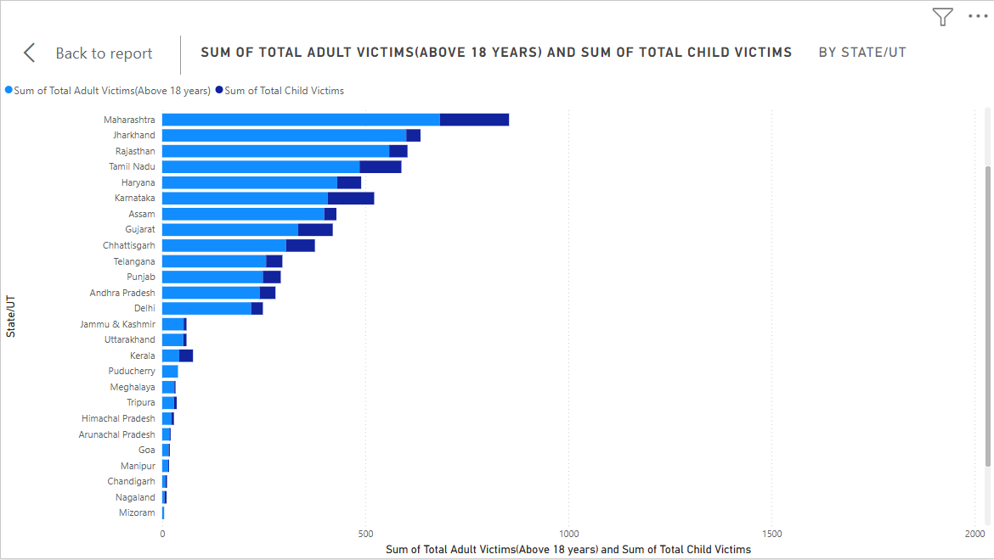

The prediction model focuses on the crime rates of children and adults in specific states around India.

The data is based on the following age groups -

1. Below 6 years
2. 6 years to 12 years
3. 12 years to 16 years
4. 16 years to 18 years
5. 18 years to 30 years

Libraries used to create the prediction model-

* **joblib** – For saving and loading machine learning models or objects.
* **pandas** – For handling and analyzing data in tabular form.
* **numpy** – For numerical operations and working with arrays.
* **matplotlib** – For creating visualizations (specifically, plots and graphs).
* **seaborn** – For statistical data visualization (built on top of matplotlib).
* **sklearn** – For machine learning tasks

**What can be done to prevent?**

1. **Education and Healthcare:** Policymakers can allocate resources effectively to meet the demand for education and healthcare.

2. **Workforce Development:** Businesses can develop strategies to attract and retain young adults and middle-aged adults.

3. **Social Services:** Policymakers can develop social services that cater to the specific needs of older adults.

4. **Economic Development:** Policymakers can develop economic development strategies that take into account the age demographics.

**Actions you can take to reduce crime on a personal level:**

* Mentor youth and spread awareness about education and mental health.
* Report suspicious activities and assist authorities.
* Secure your personal belongings.
* Promote online safety and use technology responsibly.
* Volunteer for programs focused on youth, rehabilitation, or crime prevention.
* Teach children and peers about moral values, empathy, and ethical decision-making.